AP Spanish Exam Format:
The exam is approximately 3 hours long and includes both a 95 minute multiple-choice section and an 85 minute free-response section. The multiple-choice section accounts for 50% your exam grade, and the free-response section for the other 50%.
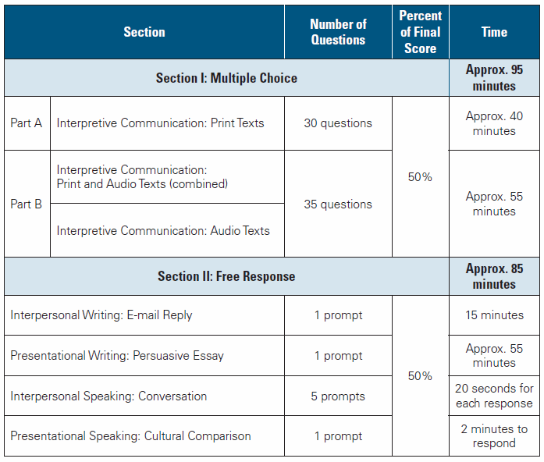
Section I: Multiple Choice
Part A: Interpretive Communication: Print Texts — 30 questions; approximately 40 minutes
This section consists of a variety of authentic print materials (e.g., journalistic and literary texts, announcements, advertisements, letters, charts, maps, and tables). You will respond to questions about these authentic materials that ask for main ideas and supporting details, questions about the meaning of vocabulary words in context, as well as questions that ask you about the author’s point of view or the target audience.
Part B: Interpretive Communication: Print and Audio Texts (combined), followed by Audio Texts: 35 questions, approximately 55 minutes.
This section consists of a variety of authentic audio materials, including interviews, podcasts, public service announcements, conversations, and brief presentations. This section is divided into two subsections. The first subsection includes audio texts that are paired with print materials; the second consists solely of audio texts. You will have time to read a preview of each selection and skim the questions before listening to the audio. All audio texts will be played twice.
You are encouraged to take notes during this part of the exam and are given writing space for that purpose. Your notes will not be graded.
Total scores on the multiple-choice section are based on the number of questions answered correctly. Points are not deducted for incorrect answers and no points are awarded for unanswered questions.

Section II: Free Response — Approximately 85 minutes
Interpersonal Writing: Email Reply
You read an email and write a reply in which you must respond to questions and provide requested information. You have 15 minutes to read the email and respond to it. (12.5% of final grade)
Presentational Writing: Persuasive Essay
You are given an essay prompt and three authentic sources (an article, a chart, graph, or table, and an audio source) which represent different points of view about the topic of the prompt. You then prepare and write a persuasive essay in which you state your point of view and integrate information from the three sources to support your perspective.. You have approximately 55 minutes to interpret the sources and write your essay. You have access to the print sources and your notes from the audio source while you write your essay. (12.5% of final grade)
Interpersonal Speaking: Conversation
You are given an outline of a conversation. You then engage in the conversation by responding to five prompts. You have 20 seconds for each response. (12.5% of final grade)
Presentational Speaking: Cultural Comparison
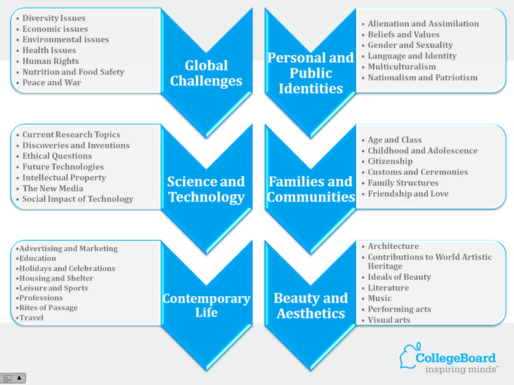
You are given a prompt about a cultural topic. Prepare and then present an oral presentation in which you compare and contrast perspectives or attitudes about this cultural topic in your community with those in a Spanish-speaking community you are familiar with. You have 4 minutes to read the prompt and prepare your answer, and 2 minutes to present and record your presentation. (12.5% of final grade)

